**University of Michigan – Dearborn**

**Department of Computer and Information Science**

**CIS 150L – Fall 2014**

Lab 9

Srinivas Simhan

11/10/14

**Table of Content**

1. Question 1 3
   1. Screenshot 3
   2. Source Code 3
2. Question 2 4
   1. Screenshot 4
   2. Source Code 4
3. Question 3 5
   1. Screenshot 5
   2. Source Code 5
4. **Question 1**
   1. **Screenshot**

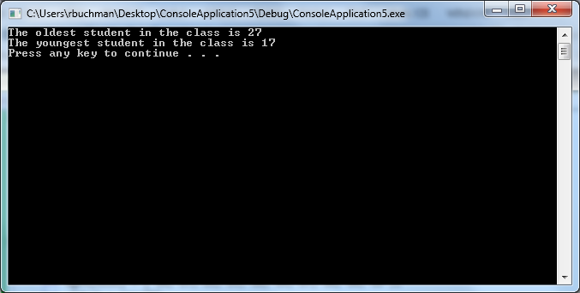

* 1. **Source Code**

//Purpose: Youngest and Oldest in Class

//Author: Srinivas Simhan

//Date Created: 11/10/14

//Date Modified: 11/10/14

#include <iostream>

using namespace std;

const int SIZE = 10;

int main()

{

int ages[SIZE] = { 18, 17, 21, 25, 18, 19, 27, 18, 20, 22 };

int oldest = ages[0];

int youngest = ages[0];

for (int i = 0;

i < SIZE;

i++)

{

if (ages[i] > oldest)

oldest = ages[i];

if (ages[i] < youngest)

youngest = ages[i];

}

cout << "The oldest student in the class is " << oldest << endl;

cout << "The youngest student in the class is " << youngest << endl;

system("pause");

return 0;

}

1. **Question 2**

**2.1 Screenshot**

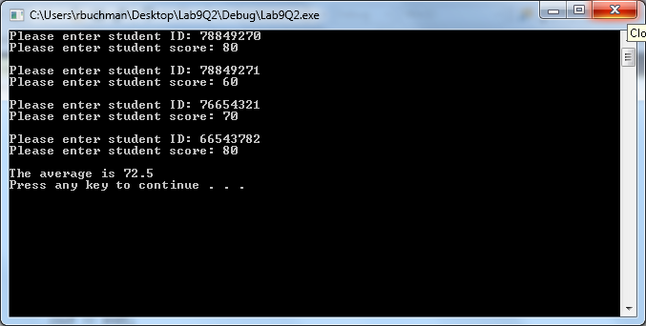

**2.2. Source Code**

// Purpose: Average Score of Multiple Students

// Author: Srinivas Simhan

// Date Created: 11/10/14

// Date Modified: 11/10/14

#include <iostream>

#include <string>

using namespace std;

int const SIZE = 4;

struct student

{

string id;

float score;

};

int main()

{

student myArray[SIZE];

float sum = 0;

float avg;

for (int i = 0;

i < SIZE;

i++)

{

cout << "Please enter student ID: ";

cin >> myArray[i].id;

cout << "Please enter student score: ";

cin >> myArray[i].score;

cout << endl;

sum = sum + myArray[i].score;

}

avg = sum / SIZE;

cout << "The average is " << avg << endl;

system("pause");

return 0;

}

1. **Question 3**

**3.1 Screenshot**

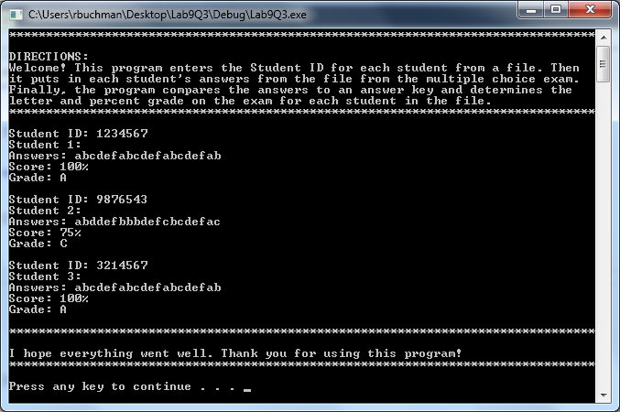

**3.2. Source Code**

// Purpose: Grade Checker for Each Student for an Exam

// Author: Srinivas Simhan

// Creation Date: 11/03/14

// Last Modification Date: 11/10/14

#include <iostream>

#include <fstream>

#include <string>

using namespace std;

float computeScore(string);

char determineGrade(float);

void instructions();

void ending();

int j = 0;

const int NB_QUESTIONS = 20;

const string ANSWER_KEY = "abcdefabcdefabcdefab";

int main()

{

string id, answer;

char letterGrade;

float score1;

instructions();

ifstream key;

key.open("answers.txt");

while (!key.eof())

{

key >> id;

cout << "Student ID: " << id << endl;

key >> answer;

j = j + 1;

score1 = computeScore(answer);

letterGrade = determineGrade(score1);

for (int i=0;

i < j;

i++)

{

cout << "Student " << j << ": " << endl;

cout << "Answers: " << answer << endl;

cout << "Score: " << score1 << "%" << endl;

cout << "Grade: " << letterGrade << endl << endl;

i = i + j;

}

}

ending();

system("pause");

return 0;

}

// Purpose: This function compares answer to ANSWER_KEY

// Author: Srinivas Simhan

// Creation Date: 11/03/14

// Last Modification Date: 11/03/14

float computeScore(string answer)

{

float score;

int correct = 0;

for (int i = 0;

i < NB_QUESTIONS;

i++)

{

if (ANSWER_KEY.at(i) == answer.at(i))

correct++;

}

score = (correct * 100) / NB_QUESTIONS;

return score;

}

// Purpose: This function returns the letter grade for the given score

// Author: Srinivas Simhan

// Creation Date: 11/03/14

// Last Modification Date: 11/03/14

char determineGrade(float score)

{

char grade;

if (score >= 90)

grade = 'A';

else if (score < 90 && score >= 80)

grade = 'B';

else if (score < 80 && score >= 70)

grade = 'C';

else if (score < 70 && score >= 60)

grade = 'D';

else if (score < 60 && score >= 50)

grade = 'E';

else if (score < 50)

grade = 'F';

return grade;

}

// Purpose: Gives you directions about what the program does and how to use it

// Author: Srinivas Simhan

// Creation Date: 11/10/14

// Last Modification Date: 11/10/14

void instructions()

{

cout << "********************************************************************************" << endl;

cout << "DIRECTIONS:" << endl;

cout << "Welcome! This program enters the Student ID for each student from a file. Then " << endl;

cout << "it puts in each student's answers from the file from the multiple choice exam. " << endl;

cout << "Finally, the program compares the answers to an answer key and determines the " << endl;

cout << "letter and percent grade on the exam for each student in the file." << endl;

cout << "********************************************************************************" << endl;

}

// Purpose: Thanks you for using the program

// Author: Srinivas Simhan

// Creation Date: 11/10/14

// Last Modification Date: 11/10/14

void ending()

{

cout << "********************************************************************************" << endl;

cout << "I hope everything went well. Thank you for using this program!" << endl;

cout << "********************************************************************************" << endl;

}